**Project 1**

1.Create a simple count plot for a single categorical variable “room_type”.

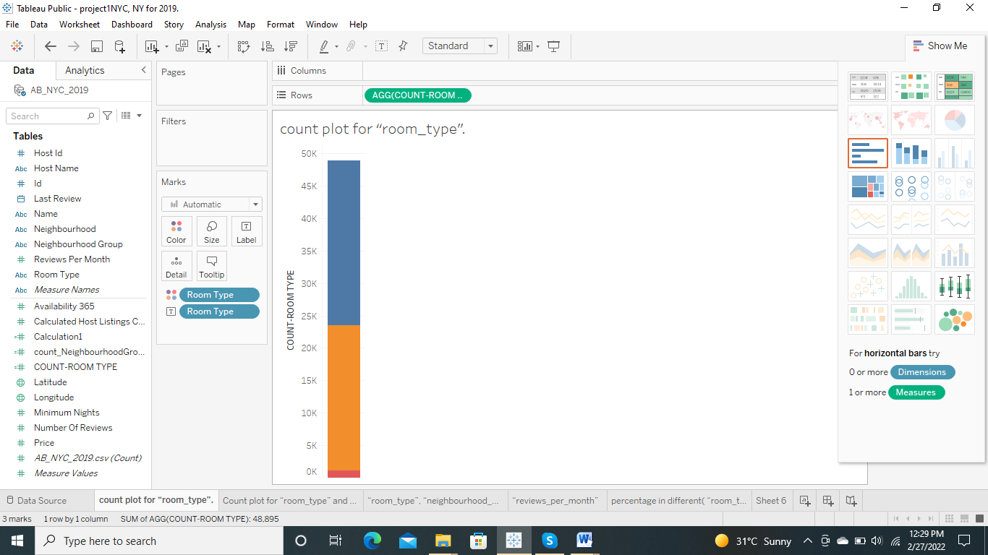

2.Create a count plot for two categorical variables “room_type” and “neighbourhood_group”

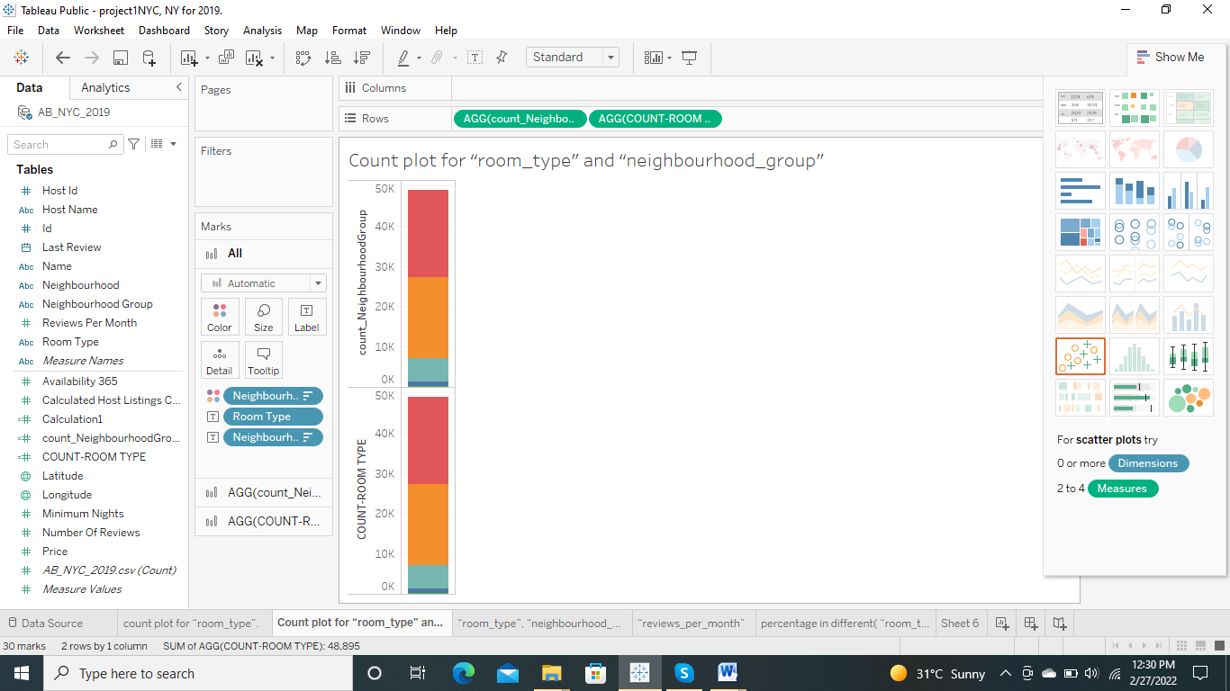

3.Create a count plot for three categorical variables “room_type”, “neighbourhood_group” and “price_group”

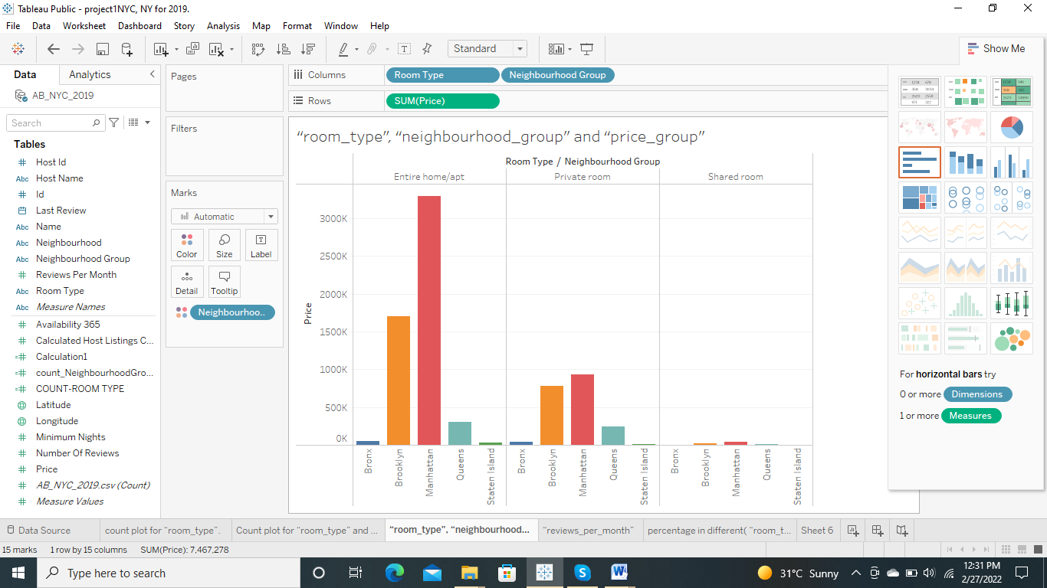

4.Create a scatter plot between “price” and “reviews_per_month”.

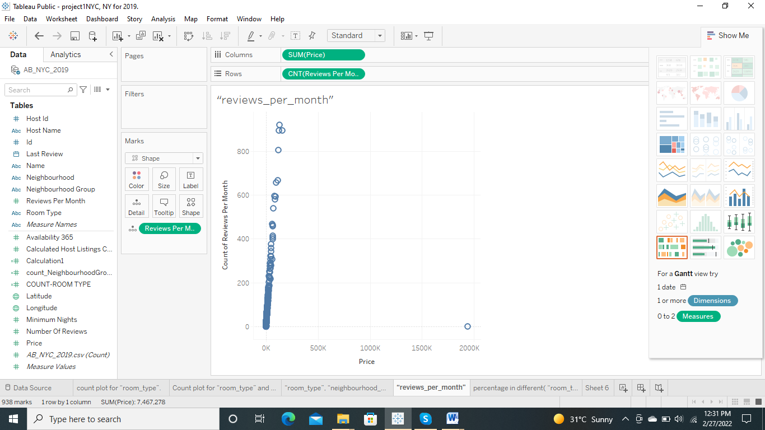

5.Create a pie chart for find which “room_type” has higher percentage in different “neighbourhood_group”.

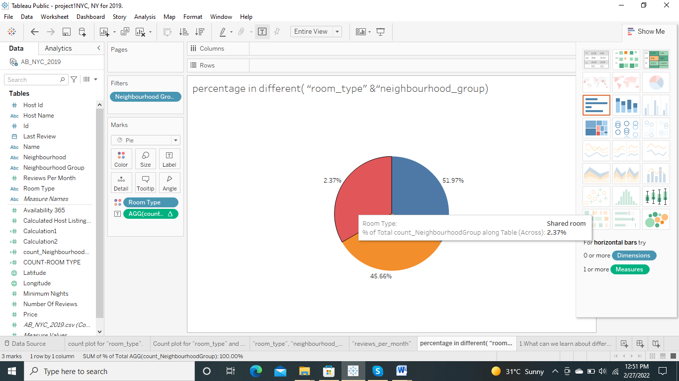

Indirect Questions (You have to decide graph type and conclude)

1. What can we learn about different hosts and areas?
2. What can we learn from predictions? (ex: locations, prices, reviews, etc)

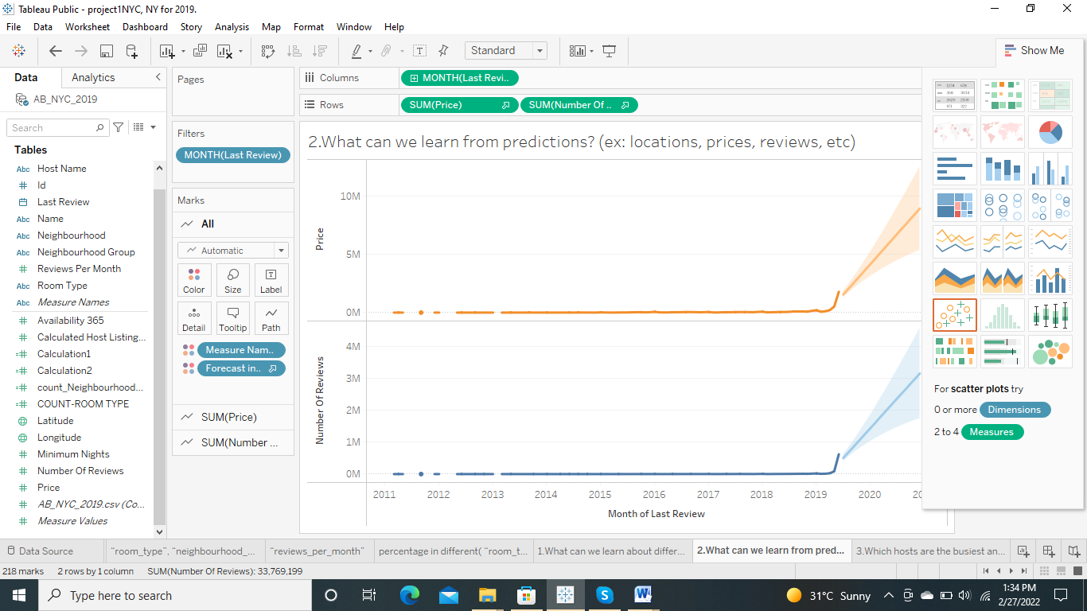

1. Which hosts are the busiest and why?

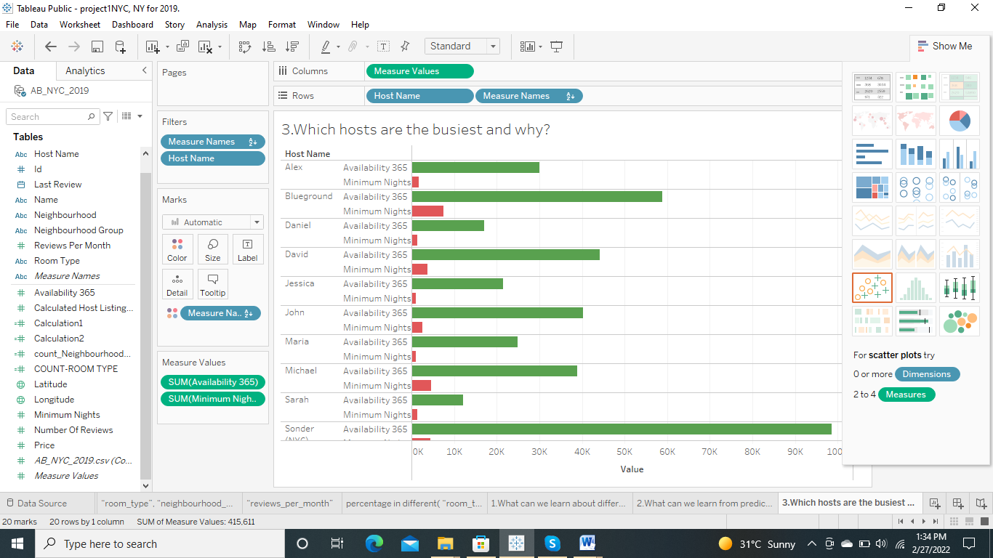

4.Is there any noticeable difference of traffic among different areas and what could be the reason for it?

